**Report of Lab 2. Programming of Robot - Tachymeter**

Name: Nian LIU Matriculation Number: 3294622

1. **Main task**

Compute of the position of the tachymeter and determine two new object points (N5, N6) by the use of the polar elements.

1. **Description**

This part we describe the performed steps. In this lab we have six parts of task:

1. **Readout of the measurement data**

**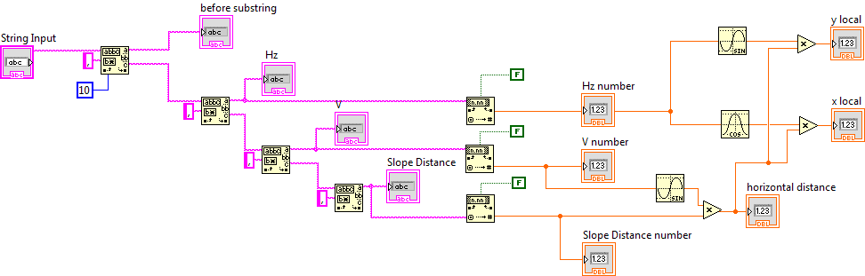**

***Figure 1. Readout of the Measurement Data***

To get started, we need to build a new string input, to link to the text answer we’ve got the last lab. We set the “regular expression” as a comma, to extract every value that divided by comma. By using this function three times we can obtain our “Horizontal angle”, “Vertical angle” and “Slope distance” values. At this time the output still be format “string”, then add a function named “Fract/Exp String To Number” to change those string into numbers. Change the “using system decimal point” into “false” to reduce the error by using german decimal point.

This part shows as figure 1, and we served it as a sub-VI. Now we have our measurement data in format number.

1. **Reduction of slope distances**

In this part, we have to change slope distances into horizontal distance. Details see in figure 2.

Using

with

the horizontal distance in polar coordinate.

the slope distance.

the vertical angle.

****

***Figure 2. Reduction of slope distances***

These steps can be finished by LabView’s compute part “Mathematics”, and put them into a sub-VI. Now we finish this part.

1. **Computation of local coordinates**

To get local coordinates, we have to transform the polar elements (horizontal distance + horizontal angle) into local cartesian coordinates (y, x) by following formula:

With

the local cartesian coordinates.

the horizontal distance in polar coordinate.

the horizontal angle in polar coordinate.

This part also shows in figure 2. Also we make them into a sub-VI, as follows.

F:\Kinematic\lab2\Lab2 final\Print\lab2__Shimeng__LIc.gif

***Figure 3. Reduction of slope distances***

1. **Transformation to global reference system using Helmert Transformation**

In this step we transform the local coordinates (y, x) into the reference system (Y, X) by a Helmert-transformation.

First, we assume there is a central of the system, to find coordinates of centroid we have:

in local system, and

in reference system.

Then, shift the original points to the centroid:

with n the number of identical points.

After this we can use the Helmert formula to compute transformation parameters *o* and *a*:

Now that we have the transformation parameters, we can compute coordinates of station (instrument site) using the given station coordinates (Ys, Xs) in reference system.

The scale factor *m* is

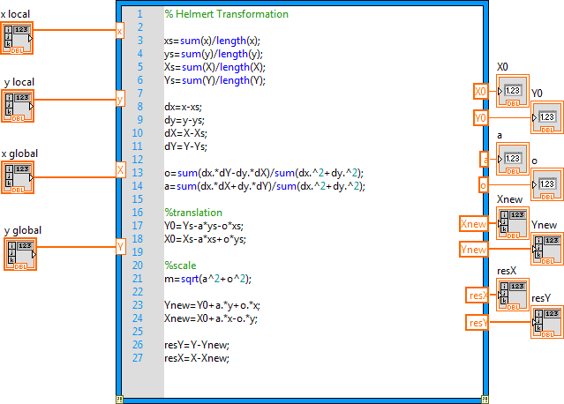

***Figure 4. Reduction of slope distances***

This part is completed by a math script, shows as figure 4.

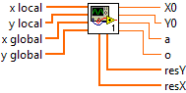

***Figure 5. Sub VI of inputs and outputs***

And it shows as a sub-VI as figure 5.

For the residuals we have

for check purpose,

The achieved accuracy can be estimated by standard deviation of the coordinates:

for check purpose,

In this judgement frame, a while loop with case structure has been made. It located between the measurements and the Helmert-Transformation. The function of this loop is manually by experimenter to delete wrong measurements.

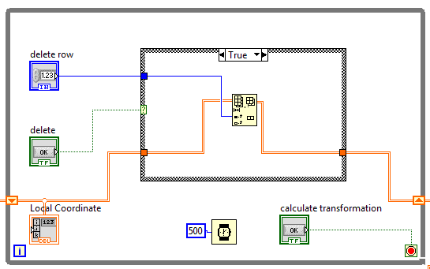

***Figure 6. Check points with true condition***

If the condition fulfills, the ‘false’ part will be carried out: doing nothing, just go to the following steps.

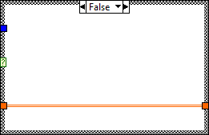

***Figure 7. False condition***

After this while loop, all local points with large residuals will be ticked out, thus those left points can go on next step’s compute.

1. **Determination of the coordinates for two new object points N5 and N6.**

In last step we have already got the transform parameters *o* and *a,* then we can compute the coordinates for two new object points N5 and N6.

Same as lab 1, here we need two while loop to control the tachymeter, send request to it and get the response, then transform these responses through a sub-VI (as figure 2 shows) into local coordinates.

Theorical, we have to transform the measured polar elements into the local yx-system:

Then, using re-transformation to get the new points. Shows as figure 8.

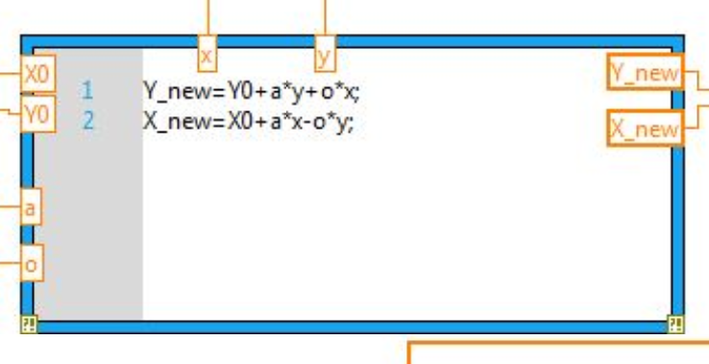

***Figure 8. Re-transformation to get new point coordinates***

These steps can be finished by LabView’s compute part “Mathematics”. Now we have the global coordinates of new object points.

1. **Data storage into file**

To storage the result, we need to create a “Write text to file” in the outer loop and create a control of file (use dialog). Then drag the “Write text to file” outside but keep the connection between two parts.

Then, connect the “text input” of the control with figure 8’s output, run the whole VI file, we can store our transformed coordinates (global coordinates) of our new points.

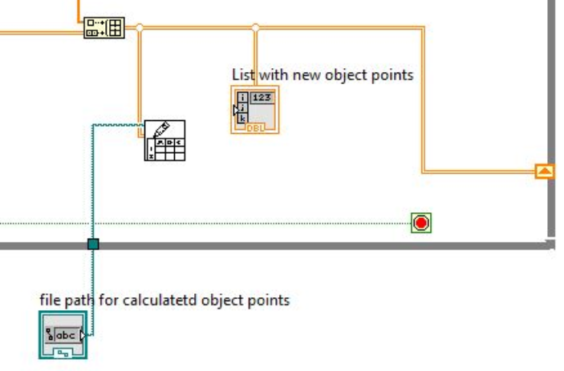

***Figure 9. Save the new point coordinates***

1. **Test result**

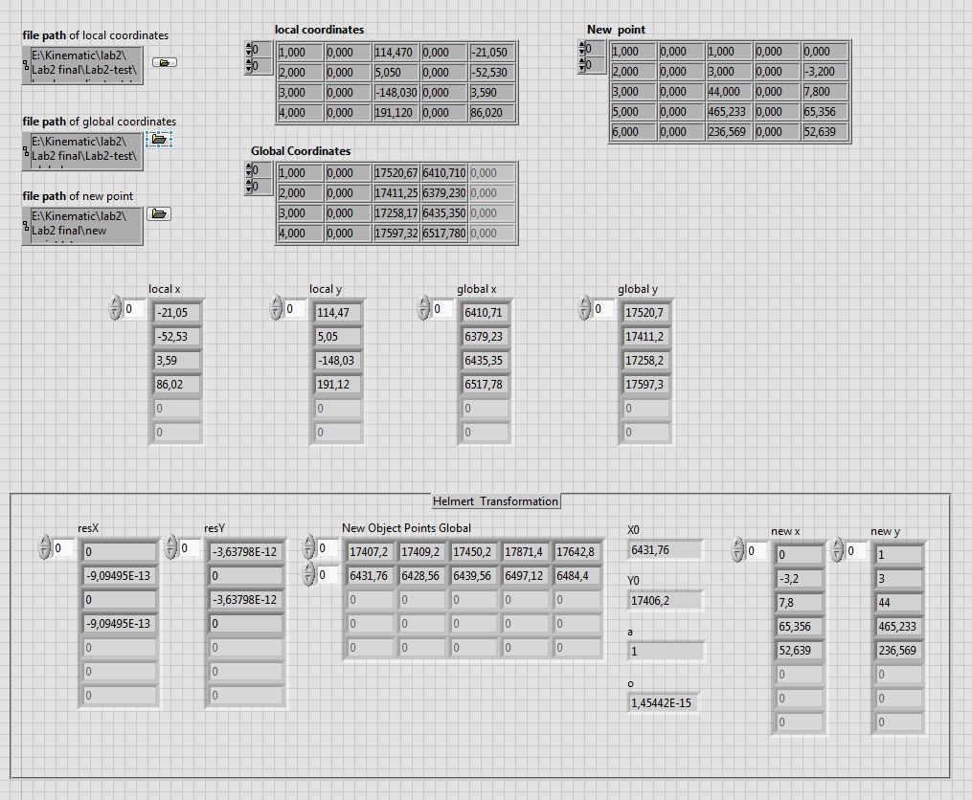

***Figure 10. test result***

Using our test program we have the new object points as figure 10. In the figure we can see, that the coordinates of the station (S) are exactly the same with in lab sheet, and our residuals are small, which also proves our program’s correctness.

N5 and N6 shows in last two rows, the result can be seen in table 1.

***Table 1. Coordinates of New Points***

|  |  |  |  |  |
| --- | --- | --- | --- | --- |
|  | New x | New y | New X | New Y |
| N5 | 65.356 | 465.233 | 6491.72 | 17871.4 |
| N6 | 52.639 | 236.569 | 6484.4 | 17642.8 |

1. **Attachments**

* Flow chart diagram
* Front panel
* Block diagram (two parts)